Case study of two Iraqi patients with Mucopolysaccharidosis (Hurler syndrome "type I" and Maroteaux-Lamy syndrome "type VI") treated with Hematopoietic Stem Cell Transplantation (HSCT)
*Furqan M. Abdulelah *, Mohammed M. Mohammed**, Rabab Hassan Baaker***
*College of Pharmacy, Al-Bayan University, Baghdad, Iraq
**College of Pharmacy, Mustansiriyah University, Baghdad, Iraq
***College of Medicine, Mustansiriyah University, Baghdad, Iraq
ـــــــــــــــــــــــــــــــــــــــــــــــــــــــــــــــــــــــــــــــــــــــــــــــــــــــــــــــــــــــــــــــــــــــــــــــــــــــــــــــــــــــــ
Article Info:

Received Nov 2022
Accepted Dec 2022
Corresponding Author email:
pharm.drmhdclinical@uomustansiriyah.edu.iq
orcid: https://orcid.org/0000-0002-5659-8713

DOI:
Abstract:
Mucopolysaccharidosis I (MPS I) or Hurler and Mucopolysaccharidosis VI (MPS VI) or Maroteaux-Lamy syndrome are infrequent genetic disorder inherited as an autosomal recessive disease attributed to genetic

variants genetic variant causing α-L iduronidase (IDUA) and arylsulfatase B (ARSB)enzyme deficiency, respectively. Here, two cases of children suffering from MPS disorder were described, the first case was MPS I while the second case was MPS VI and both cases were treated with allogenic Hematopoietic Stem Cell Transplantation approach in order to limit skeletal deterioration and retard neurocognitive alterations and hence, improve the quality of life of affected children. Following Transplantations outcomes reveal a full engraftment of donor cells as well as improvement of recipient enzymatic activity, enzyme replacement therapy post-transplantation will augment transplantation clinical outcomes. Transplantation will be more successful if the disease diagnosed early before the severe irreversible symptoms ensue.
Key words: Hematopoietic Stem Cells Transplantation, Matched donor, Hurler syndrome, Maroteaux-Lamy syndrome.
ـــــــــــــــــــــــــــــــــــــــــــــــــــــــــــــــــــــــــــــــــــــــــــــــــــــــــــــــــــــــــــــــــــــــــــــــــــــــــــــــــــــــــ
دراسة حالة لمريضين عراقيين مصابين بداء عديد السكاريد المخاطي (متلازمة هيرلر "النوع الأول" ومتلازمة ماروتو لامي "النوع السادس") تم علاجهما بزراعة الخلايا الجذعية المكونة للدم (HSCT)
فرقان محمد عبدالاله*، محمد محمود محمد**، رباب حسن باقر***
*كلية الصيدلة، جامعة البيان، العراق، بغداد
**كلية الصيدلة، الجامعة المستنصرية، العراق، بغداد
***كلية الطب،الجامعة المستنصرية، العراق، بغداد

الخلاصة:
داء عديد السكاريد المخاطية (Hurler) I و داء عديد السكارايد المخاطيVI Maroteaux-Lamy)) هي اضطراب وراثي نادر موروث كمرض وراثي متنحي يعزى إلى المتغيرات الجينية المتغيرة التي تسبب نقص او عدم فعالية α-L iduronidase (IDUA) و arylsulfatase B (ARSB) ، على التوالي . هنا ، تم وصف حالتين من الأطفال الذين يعانون من اضطراب MPS ، الحالة الأولى كانت MPS I بينما كانت الحالة الثانية MPS VI وتم علاج كلتا الحالتين بنهج زرع الخلايا الجذعية المكونة للدم من أجل الحد من تدهور الهيكل العظمي وتأخير التغيرات المعرفية العصبية وبالتالي تحسين نوعية حياة الأطفال المصابين. تكشف نتائج عمليات الزرع التالية عن اندماج كامل لخلايا المتبرع بالإضافة إلى تحسين النشاط الأنزيمي للمتلقي ، فإن العلاج ببدائل الإنزيم بعد الزرع سيزيد من النتائج السريرية للزرع. ستكون عملية الزرع أكثر نجاحًا إذا تم تشخيص المرض مبكرًا قبل ظهور الأعراض الشديدة التي لا رجعة فيها.

الكلمات المفتاحية: زرع الخلايا الجذعية المكونة للدم ، المتبرع المتطابق، متلازمة هيرلر ، متلازمة ماروتو لامي.

Introduction
The Mucopolysaccharidosis (MPS) is a rare genetic progressive disorder that is a subgroup of a lysosomal storage disease (LSD) resulting in an intralysosomal accumulation of glycosaminoglycans (GAGs) due to the absence or deficit of specialized catabolic enzymes responsible for hydrolysis of GAGs. Seven different phenotypes of MPS (MPSs I, II, III, IV, VI, VII and IX) have been described attributed to eleven enzymatic deficiency^{[1]}. There are no evident associations between phenotype and genotype of the disease entity^{[2-4]}.
Mucopolysaccharidosis I (MPS I) is a rare autosomal recessive disease with birth prevalence 0.25 per 100,000 live births as revealed in epidemiological studies carried out in United Arab Emirates (UAE), MPS I considered when a genetic variant causing α-L iduronidase (IDUA) enzyme deficiency is confirmed, the enzyme encoded by IDUA gene located in 4p16.3 chromosome^{[5]}. Until now, 286 mutations have been reported in MPS I patients. Deficiency of this enzyme characterized by excessive intralysosomal storage of proteoglycans dermatan sulfate (DS) and heparan sulfate (HS) leading to multiorgan impairments and / or damage. MPS I is subdivided into three subtypes based on the severity of manifested clinical symptoms: severe, intermediate and mild which are known as Hurler syndrome, Hurler-Scheie syndrome and Scheie syndrome, respectively^{[6]}. Current therapeutic options available for treatment of MPS I patients are: Enzyme replacement therapy (ERT) with laronidase and Hematopoietic stem cell transplantation (HSCT). Somatic disease manifestations and progression can be improved by ERT unlike the irreversible central nervous system disease which cannot be addressed by ERT because current enzyme does not pass blood brain barrier, improved developmental consequences and preservation of cognition have been reported when HSCT commenced as early as possible and hence HSCT considered as the typical management approach for severe MPS I patients. Early identification of MPS I by newborn screening or other diagnostic programs before somatic deterioration and Central Nervous System CNS involvements facilitates the choice of accurate treatment initiation^{[7, 8]}.
Mucopolysaccharidosis VI (MPS VI) or Maroteaux-Lamy syndrome is infrequent genetic disorder inherited as an autosomal recessive disease attributed to genetic variants of the gene arylsulfatase B (ARSB) located at 5q11-q13 chromosomes and coding for catabolic lysosomal enzyme N-acetylgalactosamine 4-sulftase (arylsulfatase B, ASB), until now 201 mutations have been reported in patients with MPS VI^{[9,10]}. In UAE the birth prevalence of MPS VI was 2.51 per 100,000 live births^{[5]}. The main clinical and biochemical manifestations of MPS VI are caused by intralysosomal accumulation of GAGs chondroitin-4-sulfate and DS. MPS VI disorder is further subdivided into two subtypes, classical and non-classical, relying on age of disease onset and level of urinary GAGs, weekly intravenous infusion of ERT galsulfase as 1mg/kg proposed to limit, stop or reverse disease progression and improve patients’ survival when commenced early^{[11,12]}. Due to the rarity of Maroteaux-Lamy disease no enough information is available about long term consequences of HSCT therefore morbidity and mortality of this approach is obtained from MPS I patients who underwent HSCT^{[13]}.
Here, two cases of children suffering from MPS disorder were described, the first case was MPS I while the second case was MPS VI and both cases were treated with allogenic HSCT approach in order to limit skeletal deterioration and retard neurocognitive alterations and hence, improve the quality of life of affected children.

Case I

Clinical presentations
The first case J.N. was MPS I female patient, her age was 2-year and 4 months-old. Her weight was 12 kg (within 30 percentile) with height 84 cm (9 percentile) and head circumference 51cm (99 percentiles). J.N. was born from the first pregnancy of consanguineous carrier parents with a negative family history. The patient was presented to hospital when she was five months-old with back deformity (Figure 1), and then when she was nine months-old presented with snoring problems during which the diagnosis with MPS I was detected and confirmed genetically. The parents are first degree cousins and both of them are carriers. The patient’s cognitive development was normal (understanding speech), however there was regression at motor development (she was able to sit while she was nine months-old, she started walking when she was eighteen months-old, she can get upstairs but cannot get down). She can form three words sentences, she knows three colors, she can name seven animals. Hearing and speech speed were normal. For one year she was taking weekly ERT (α-L iduronidase enzyme therapy, Aldurazym®).

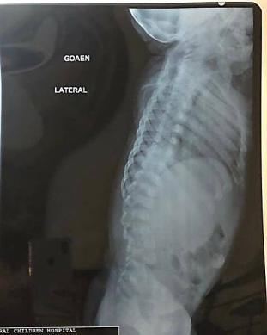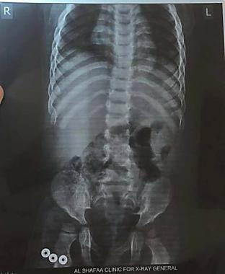
Figure (1): Lateral and anteroposterior radiography of backbone before HSCT
Diagnosis
In the beginning, biochemical assay using tandem mass spectrometry from dried blood spot (DBS) reveals α-L iduronidase enzyme activity was 0.0 µmol/L/h, while the cutoff value of the enzyme is greater than 1.5 µmol/L/h (Table 2) and therefore genetic testing was recommended for confirmation of MPS I disorder. Next generation sequencing (NGS) of all coding exon and flanking intronic regions was dependent as a genetic test for diagnosis, in which DNA was extracted from DBS. The following homozygous mutations were detected: c. [152G<A]; [152G<A] and (p. [Gly51Asp]; [Gly51Asp]). The latter is a known missense mutation and confirms MPS I.

Hematopoietic Stem Cell Transplantation
In Feb 2021, the patient was transferred to Memorial hospital in Ankara-Turkey for bone marrow transplantation. First, physical examination was made which reveal good general condition of patient, she was conscious, cooperative and oriented. Systemic examination was normal with typical face outlook, pressed nose bridge, wide head diameter, low hairline, hazy cornea, short teeth, large tongue, short fingers, lumbar lordosis, umbilical hernia, hepatosplenomegaly and joint movement limitation excluding knee and elbow joints. Afterword, complete blood count (CBC), routine biochemistry, and microbiology tests were performed indicating normal findings (Table 1). Then, the patient was transferred into transplantation service for an allogenic transplant from her 12/12 human leukocytes antigen (HLA) compatible mother. Pre-transplant tests were completed including cytomegalovirus polymerase chain reaction (CMV PCR) and viral serology indicating negative results. No problems were detected in dentistry, ophthalmology, neurology and cardiology consultations. In 25 Feb 2021, the patient’s myeloablative preparation regimen consisting of busulfan, fludarabine, and anti-thrombocytic globulin (ATG) was started simultaneously. Prophylactic antibiotics and immunosuppressive therapy started including luconazole, ciprofloxacin, cotrimoxazole, metronidazole, acyclovir. Heparin, glutamine and ursodeoxycholic acid started for hepatic veno-occlusive disease (VOD). The preparation regimen completed without complications.
In 4 March 2021, 6.2 X 10⁶ / Kg CD34 positive stem cells were collected from the bone marrow of the donor and transferred to the recipient in three hours without complications. In neutropenic process, oral care was performed as six times per day. Oral nutrition supported. Transfusions were made so that hgb would be 8 gr/dl and thrombocytes would be over 20000 /mm³. On the + 4th day, contramal® drip (tramadol) and durogesic® patch (fentanyl) were started due to throat-ache compliant. Until engraftment process occurs, once per week Aldurazym® ERT continued. At + 41st day, the patient’s chimerism result was 100% donor. At + 45th day, at inguinal and armpit regions hyperpigmentations were observed; rash occurred and it was considered grade I graft versus host disease (GVHD) and dexamethasone cream was started. Rashes were then subsided in observation. At + 48th day, acute left hemiplegia was developed, in computerized tomography CT-scan no bleeding focus was detected and heparin was started. Under anesthesia, cranial contrasted-MRI was performed and thrombus was detected in right middle cerebral artery (MCA) and enoxaparin (2 X 0.15 mL) was started. In the next day, movement detected in lower extremities. However, upper extremity movement was minimal. The patient can walk and move her left upper extremity at shoulder region. Medicine training was given to patient’s family, and discharge is planned in 30 April 2021, 2nd chimerism result is in follow up. Nowadays, the patient supported with physical therapy in which gradual improvement in extremities movement was noticed.

Table (1): Routine checkup results.
Complete Blood count | Hgb | Hct |  | Leukocytes |  | Thrombocytes
 | 13.2 g/dl | 37.8% |  | 1164/mm³ |  | 441000/mm³
Routine Biochemistry | Blood glucose | Urea |  | Creatinine |  | ALT | AST |  | Ferritin
 | 102 mg/dl | 34 mg/dl |  | 0.3 mg/dl |  | 7 U/L | 37 U/L |  | 44.58 mcg/L
Microbiology | AntiHBc T: negative |  | HBsAg: 0.438 |  | Anti-HCV: 0.034 |  |  | Anti-HIV 1-2: negative
 | Toxo IgM: 009 |  | CMV IgM: 0.20 |  | EBV IgM: 0.16 |  |  | VDRL: negative
 |  |  | CMV IgG: 224.2 |  | EBV IgG ˂2 |  |  | Quantiferon: negative
 | No parasite eggs were observed in stool and urine. Urine, gaita culture: no pathogen agent reproduced

Follow up
In 12 May 2021, follow up biochemical test was performed to check the activity of α-L iduronidase enzyme post-HSCT and demonstrate 0.9 µmol/L/h, which still below the cut-off value of enzyme activity (1.5 µmol/L/h). While, in December 2021, patient biochemical test of α-L iduronidase enzyme activity was 0.9 µmol/L/h (Table 2). Consequently, In December 2021 the enzyme activity was assessed in carrier donor mother using biochemical test, in addition to molecular test for variant identification that causing the disease. The implementation of biochemical test reveals decreased α-L iduronidase enzyme activity (0.5 µmol/L/h) while molecular test demonstrates heterozygous pathogenic missense mutation (c.152G>A (p. (Gly51Asp)). The detection of one mutation is not sufficient to confirm MPS I disorder (confirmed carrier status only)

Table (2): pre and post laboratory enzyme level
Lab. data | Pre-treatment | Post- treatment
Alpha -L-Iduronidase | 0.0µmol/L/h | 0.9 µmol/L/h

Case II

Clinical presentations
L.K. was the second case studied who was a female patient aged 1 year and 1 month-old. Her weight was 8.8 kg with height 74 cm and head circumference 45 cm (15, 40 and 41 percentiles respectively). Her newborn screening was negative, but she had club foot and operated upon. When she was 3 weeks-old she was admitted to hospital for general investigations including echocardiogram that reveals clefted mitral valve, mitral regurgitation, and mitral valve prolapse. She sits at 10-month-old, crawling at 11-month-old while words spoked were Ma, Ba, and Da only,

therefore, she was developmentally delayed. Abdominal ultrasound reveals hepatosplenomegaly where spleen was palpated 3-cm and liver 2-cm below costal margin respectively. Dysmorphic features observed where saddle nose, protruded tongue, gibbus (kyphosis) and exophthalmos. Skeletally, she was dysostosis multiplex. However, ophthalmic test was normal. L.K born from normal first pregnancy of consanguineous carrier parents with negative family history.

Diagnosis
In 14 August 2017, when patient’s age was 1 year and 2-month-old, dried blood spot was sent for biochemical and molecular diagnosis. Biochemical test was performed using fluorimetry method which reveals pathological decrease of arylsulfatase B enzyme activity (1.9 µmol/L/h) that is below the cutoff value (≥ 8,8 µmol/L/h) (Table 3). While, molecular study confirms homozygous variant c.944G˃A p(Arg315Gln) in exon 5 of ARSB gene, this variant has been previously described as disease-causing mutation and classified as pathogenic (class 1) according to Centogene and American College of Medical Genetics and Genomics (ACMG) recommendations.

Hematopoietic Stem Cell Transplantation
L.K. was transferred to Memorial hospital in Ankara-Turkey for bone marrow transplantation. First, physical examination was made which reveal good general condition of patient, she was conscious, cooperative and oriented. Systemic examination was normal with typical face outlook, pressed nose bridge, large tongue, short fingers, lumbar lordosis, umbilical hernia, normal cornea not cloudy no cherry red spots. The patient was transferred into transplantation service for an allogenic transplant from her 5/6 human leukocytes antigen (HLA) compatible mother. Pre-transplant tests were completed including CMV PCR and viral serology indicating negative results. No problems were detected in dentistry, ophthalmology, neurology and cardiology consultations. Patient’s preparation regimen consisting of busulfan, fludarabine, and anti-thrombocytic globulin (ATG) was started simultaneously. Prophylactic antibiotics started including luconazole, ciprofloxacin, trimethoprim-sulfamethoxazole, metronidazole, acyclovir. Heparin, glutamine and ursodeoxycholic acid started for hepatic veno-occlusive disease (VOD). The preparation regimen completed without complications.
6.2 X 10⁶ / Kg CD34 positive stem cells were collected from the bone marrow of the donor and transferred to the recipient in three hours without complications. Until engraftment process occurs, once per week Naglazyme® ERT continued. Medicine training was given to patient’s family.

Follow up
In 8 March 2020, follow up for L.K. carried out and reveals good general health, good sleeping, good walking normal mentality but still gibbus with lordosis. Her body weight was 15 kg and stature were 95cm (31 and 9 percentile), respectively (Figure 2). In 18 march 2021, DBS sample was sent for screening of arylsulfatase B enzyme activity by tandem mass spectrometry, the result show normal enzyme activity 3.4 µmol/L/h in comparison with enzyme cutoff value ˃1.0
µmol/L/h (Table 3).

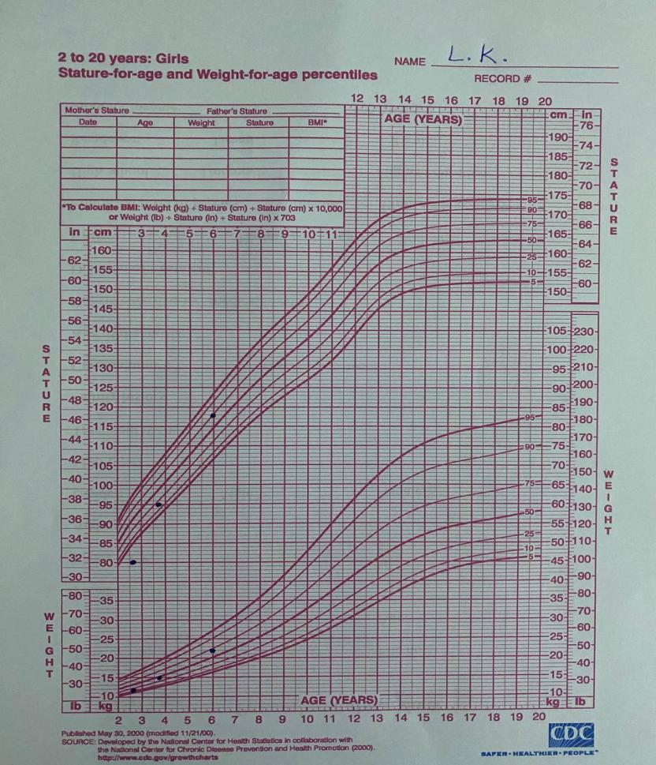
Figure (2): Stature for age and Weight for age percentile.

Table (3): pre and post laboratory enzyme level
Lab. data | Pre-treatment | Post- treatment
Arylsulftase B | 1.9 µmol/L/h | 3.4 µmol/L/h

Discussion
Hematopoietic stem cell transplantation is a promising therapy that can deliver the enzyme for lifelong in an enzyme-deficient patients in contrast to ERT that temporarily deliver the enzyme and cannot cross the blood brain barrier, the benefit of HSCT is its ability to allocate and differentiate as a Kupffer cells, microglial cells and alveolar macrophages in liver, brain and lungs respectively^{[14,15]}. Furthermore, cross-correction phenomenon has been noticed by which the enzyme-deficit neighboring cells will be supplied by the enzyme from engrafted cells with a consequent sustained metabolic rectification and improved somatic and neurocognitive problems^{[16]}.

However, HSCT is not without limitations, in which difficulty in finding compatible donor and risk-procedure related morbidity and mortality as well as GVHD are the main obstacles reported^{[17]}. In this context, the first fruitful HSCT for MPS I Hurler patient was executed in 1980, allowing the treatment of hundreds of Hurler syndrome cases. If HSCT was carried out earlier than seventeen months of age significant improvement with higher rate of disease-free survival were observed^{[18, 19]}.
Even though the rarity of using HSCT globally for MPS VI patients, long-term follow-up for MPS VI patients underwent HSCT had revealed that stable engraftment and improved activity of the enzyme in patients would be obtained following HSCT with myeloablative routine using cord blood or peripheral blood of HLA-compatible unaffected donor^{[20, 21]}.
Survival rate and successful engraftment post-transplantation has improved after implementation of myeloablative regimen and individual-related immunosuppressive strategies as reported by Su HanLum et al (2021) study^{[22]}.
In this case report, J.N patient (case I with MPS I disorder) was treated with HSCT that carried out when she was 2 year and 8 months of age from her 12/12 HLA-matched heterozygous carrier mother. Long- term follow-up shown an improvement in general health and increment in enzyme activity although it still below the cut-off value of unaffected subjects, but the doctors wonder that will J.N. has normal life as her carrier mother, in which her mother also has enzyme activity below normal cut-off. Therefore, doctors advise J.N. parents to continue ERT therapy after HSCT for greater benefit as the result of Troy C. Lund et al (2019) study reveal ERT post-transplant augmentation would significantly improve the clinical outcomes^{[23]}. Other features, like scoliosis, cannot be corrected by HSCT and hence, surgical intervention is to be considered.
L.K patient (case II with MPS VI) was stabilized with HSCT when she was 4 years old after receiving the retrieved 6.2 X 10⁶ / Kg CD34 positive stem cells from her 5/6 human leukocytes antigen (HLA) compatible mother. Long-last follow-up studies revealed an improvement in a clinical outcome as a resolution of somatic complications like course facial characteristics. However, this patient still gibbus with lordosis therefore surgical intervention is advisable. Biochemical follow-up documented an increment in enzyme activity above the cut-off level which confirm the successfulness of the engraftment.
In conclusion, HSCT can stop progression of the disease and improve patients’ general-health and survival. This treatment maneuver will be more successful if the disease diagnosed early before the severe irreversible symptoms ensue. There are still several limitations to cope such as finding matched donors and reducing the procedure- associated morbidity and mortality risks. Otherwise, due to rarity of MPS-VI, there are insufficient information about the effectiveness of HSCT compared with other therapeutic strategies such as ERT. Future multicenter study is considered for early and precise diagnosis and recognition of MPS patients, newborn screening should be encouraged to decide the commence of best treatment approaches based on the patients’ condition.

Acknowledgement
We thank so much Dr. Arabia Aidayn for her support in collecting data from Child’s Central Teaching Hospital / Metabolic diseases unit / Baghdad.

References
- Kobayashi HJJoHG. Recent trends in mucopolysaccharidosis research. 2019.64(2):127-37.
- Alaqidi AAH, Alwash MMJAMJoPS. Association of GSTP1 Ile-105-Val Gene Polymorphism with Response to Treatment Among Iraqi Chronic Myeloid Leukaemia Patients. Al Mustansiriyah Journal of Pharmaceutical Sciences. 2018.18 (2):133-41.
- Shaheed HS, Abbass WA-K, Jasim SYJAMJoPS. Studying Cytotoxic T-lymphocyte-Associated Antigen-4 (CTLA-4) gene Polymorphism in a Sample of Iraqi Women with Polycystic Ovarian Syndrome. Al Mustansiriyah Journal of Pharmaceutical Sciences. 2019. 19(4):1-6.
- Hameed FG, Arif IS, Mohammed MM, Arif HSJAMJoPS. Co-occurrence of Wilson disease and Auto-Immune Hepatitis in 14-year-old female: A case report. Al Mustansiriyah Journal of Pharmaceutical Sciences. 2021.21(2):1-8.
- Al-Jasmi FA, Tawfig N, Berniah A, Ali BR, Taleb M, Hertecant JL, et al. Prevalence and novel mutations of lysosomal storage disorders in United Arab Emirates. JIMD Reports. 2013; Volume 10:. p:1-9.
- Wraith J, Jones SJPERP. Mucopolysaccharidosis type I. Pediatric Endocrynology Reviews. 2014.12(1):102-6.
- Hampe CS, Eisengart JB, Lund TC, Orchard PJ, Swietlicka M, Wesley J, et al. Mucopolysaccharidosis type I: A review of the natural history and molecular pathology. cells. 2020.9(8):1-26.
- Polgreen LE, Lund TC, Braunlin E, Tolar J, Miller BS, Fung E, et al. Clinical trial of laronidase in Hurler syndrome after hematopoietic cell transplantation. Pediatric Research. 2020.87(1):104-11.
- Vairo F, Federhen A, Baldo G, Riegel M, Burin M, Leistner-Segal S, et al. Diagnostic and treatment strategies in mucopolysaccharidosis VI. The Application of Clinical Genetics. 2015.8:245-55.
- Leiro B, Phillips D, Duiker M, Harmatz P, Charles SJOjord. Mucopolysaccharidosis type VI (Maroteaux-Lamy syndrome): defining and measuring functional impacts in pediatric patients. Orphanet Journal of Rare Diseases. 2021.16(1):1-13.
- Brunelli MJ, Atallah ÁN, da Silva EMJCDoSR. Enzyme replacement therapy with galsulfase for mucopolysaccharidosis type VI. Cochrane Database of Systematic Reviews. 2021 Sep 17.9(9):1-28.
- Quartel A, Harmatz PR, Lampe C, Guffon N, Ketteridge D, Leão-Teles E, et al. Long-term galsulfase treatment associated with improved survival of patients with mucopolysaccharidosis VI (Maroteaux-Lamy syndrome): 15-year follow-up from the survey study. Journal of Inborn Errors of Metabolism & Screening. 2019.6:1-6.
- Behfar M, Dehghani SS, Rostami T, Ghavamzadeh A, Hamidieh AAJPt. Non‐sibling hematopoietic stem cell transplantation using myeloablative conditioning regimen in children with Maroteaux‐Lamy syndrome: A brief report. Pediatric Transplantation. 2017.21(5):1-4.
- Lum SH, Stepien KM, Ghosh A, Broomfield A, Church H, Mercer J, et al. Long term survival and cardiopulmonary outcome in children with Hurler syndrome after haematopoietic stem cell transplantation. Journal of Inherited Metabolic Disease 2017.40(3):455-60.
- Sisinni L, Pineda M, Coll MJ, Gort L, Turon E, Torrent M, et al. Haematopoietic stem cell transplantation for mucopoly saccharidosis type VII: a case report. Pediatric Transplantation. 2018 .22(7):1-6.
- Guffon N, Pettazzoni M, Pangaud N, Garin C, Lina-Granade G, Plault C, et al. Long term disease burden post-transplantation: three decades of observations in 25 Hurler patients successfully treated with hematopoietic stem cell transplantation (HSCT). Orphanet Journal of Rare Diseases 2021.16(1):1-20.
- Hwu W-L, Okuyama T, But WM, Estrada S, Gu X, Hui J, et al. Current diagnosis and management of mucopolysaccharidosis VI in the Asia-Pacific region. Molecular Genetics and Metabolism. 2012.107(1-2):136-44.
- Vashakmadze ND, Namazova-Baranova LS, Zhurkova NV, Zakharova EY, Mikhaylova SV, Revunenkov GVJCP. Enzyme Replacement Therapy and Hematopoietic Stem Cell Transplantation Results in Patients with Hurler Syndrome: Clinical Cases. Current Pediatrics. 2019.18(3):196-202.
- Gentner B, Tucci F, Galimberti S, Fumagalli F, De Pellegrin M, Silvani P, et al. Hematopoietic stem-and progenitor-cell gene therapy for Hurler syndrome. the New England Journal of Medicine. 2021.385 (21):1929-40.
- Lin H-Y, Huang Y-H, Lei S-Y, Chen L-J, Lin S-PJTJoO. Clinical ocular manifestations of Taiwanese patients with mucopolysaccharidoses VI (Maroteaux–Lamy syndrome). Taiwan Journal of Ophthalmology. 2019.9(3):194-7.
- Andrade I, Ribeiro R, Carneiro ZA, Giugliani R, Pereira C, Cozma C, et al. Fifteen years of enzyme replacement therapy for mucopolysaccharidosis type VI (Maroteaux–Lamy syndrome): a case report. Journal of Medical Case Reports 2022.16(1):1-5.
- Lum SH, Orchard PJ, Lund TC, Miller WP, Boelens JJ, Wynn RJT, et al. Outcome after cord blood transplantation using busulfan pharmacokinetics-targeted myeloablative conditioning for hurler syndrome. Transplantation and Cellular Therapy. 2021.27(1):1-4.
- Lund TC, Miller WP, Liao AY, Tolar J, Shanley R, Pasquali M, et al. Post-transplant laronidase augmentation for children with Hurler syndrome: Biochemical outcomes. Scientific Reports 2019.9(1):1-6.

